Python Based Battery Control System for Smart Energy Grid Integration

ENGN4200 Individual Project Thesis

Patrick Wilton | 2019

A thesis submitted for the degree of Bachelor of Engineering (Honours)

Research School of Electrical, Energy and Materials Engineering

*I declare that this thesis is my own original work except where acknowledgement of another source has been made.*

Patrick Wilton

9th September 2019

# Acknowledgements

I would personally like to thank my supervisor Lachlan Blackhall for providing me with this research opportunity even with my small amount of control systems knowledge going into this project. Although he was often busy throughout my time completing my honours, his words of encouragement and support kept me from becoming overwhelmed with the tasks ahead, especially in the early days.

I have greatly appreciated the advice of BSGIP team member Benjamin Weise. His words of wisdom helped me through many technical software issues even if I was often able to answer my own questions by simply explaining them to him.

I would also like to thank Bjorn Sturmberg for committing the time to be my secondary supervisor where needed and the entire BSGIP team for their welcoming attitude, especially Deborah Taylor for being so patient with my late email replies.

# Abstract

Written after Results

Table of Contents

Acknowledgements 3

Abstract 4

List of Figures 6

List of Tables 6

Nomenclature 7

1. Introduction 8

1.1 Thesis Statement 8

1.2 Residential Battery Control System Dynamics 8

1.3 Input Data Systems 13

1.4 Battery Models 13

1.5 Motivations 14

1.6 Thesis Outline 14

2. Background and Related Work 15

2.1 Existing Battery Systems 15

2.2 Current Viability Research 15

2.3 BSGIP’s Work 15

3. A Python Based Battery Control System 16

3.1 Hardware Simulation and Program Abstraction 16

3.2 System Capabilities and Limitations 16

3.3 Testing Methods 16

3.4 Results 16

4. Discussion 17

4.1 Technical Assumptions 17

4.2 Results Implications 17

4.3 Financial Incentives 17

5. Conclusions 18

5.1 Battery Systems’ Current Viability 18

5.2 An Open-Source Solution 18

Bibliography 19

# List of Figures

Figure 1: High-Level Sub-Systems 8

Figure 2: PV Self-Consumption Closed Loop Control System 9

Figure 3: Typical PV-Self Consumption Battery 24 Hour Response 9

Figure 4: Peak Minimisation Closed Loop Control System 10

Figure 5: Typical Peak Minimisation Battery 24 Hour Response 10

Figure 6: Load-Shifting Open-Loop Control System 11

Figure 7: Optimisation Battery Control System 13

Needs Updating

# List of Tables

Table 1: Generalised Comparison of Typical Battery Control Methods 12

Needs Updating

# Nomenclature

BSGIP: Australian National University Battery Storage and Grid Integration Program

SOC: State of Charge

DOD: Depth of Discharge

PV: Photo-Voltaic

Needs Updating

# Introduction

## Thesis Statement

Current residential energy storage solutions for solar use fail to be financially viable for a vast majority of their Australian customers, where many of the battery options on offer use only simple control methods focusing on PV self-consumption, load-shifting or small amounts of peak minimisation. A higher level of control involving input predictions and output optimisations will provide significant benefits over these systems in many cases. Specifically, a python-based system which simulates hardware protocols can be used to test these different battery control methodologies, provide a valuable insight for customers, and could help improve these systems in the future when energy storage becomes a much more viable addition to the Australian solar powered home.

## Residential Battery Control System Dynamics

It is useful for the purposes of PV systems to think of energy storage not as its name suggests but as a form of control input. The addition of a battery to a PV system does not mean any additional energy is produced or consumed, but rather energy can now be controlled in a different way. This inherently means that the battery is not an isolated system and relies on at least one input to produce at least one output that will affect the state of the system. This residential PV network can, at its highest level, be represented by four distinct sub-systems:

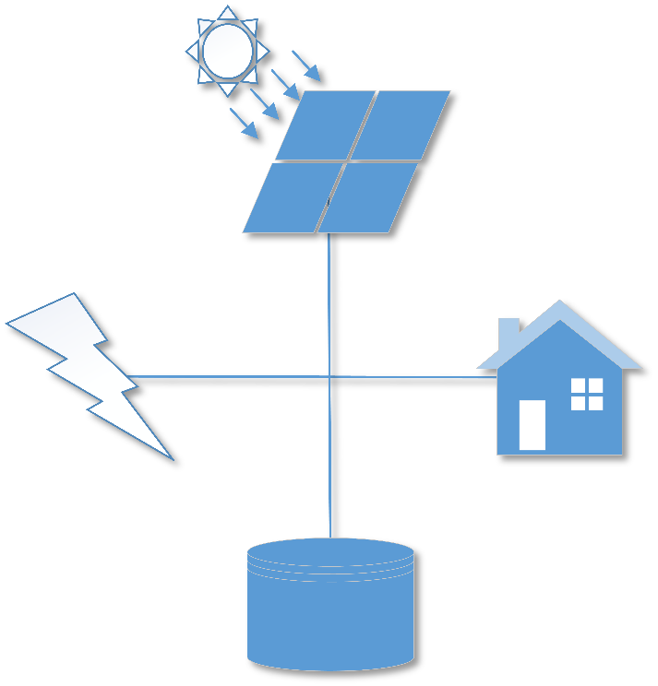

Figure : High-Level Sub-Systems

Figure 1 shows each of the four sub-systems involved: solar (top), the grid (left), the house/load (right), and the battery (bottom). Broken down at this level, each of these sub-systems are related in the following way:

$$Grid=Battery+House+Solar$$

This equation of course assumes values for these systems are in terms of power and there is no energy lost due to any external or internal factors. The relationship between these sub-systems also implies that only three out the four values needs to be known to effectively control the system, as the other can be inferred. Generally, this unknown is either the house/load or the grid as the solar and battery values are often more accessible due to them both being controlled systems put in place by the user. What this means is that by simply measuring the solar intake and house energy consumption (or the grid power), enough data is available for a simple control system to effectively use the battery to negate much of the need for import grid power within the battery’s capacity and efficiency limits. The most clear first approach in this control is effectively make the grid (‘zero the gird’), in other words, battery power is applied at appropriate times with respect to the following equation;

$$Battery+House+Solar=0$$

This is called PV self – consumption, and can be represented functionally by the following diagram:

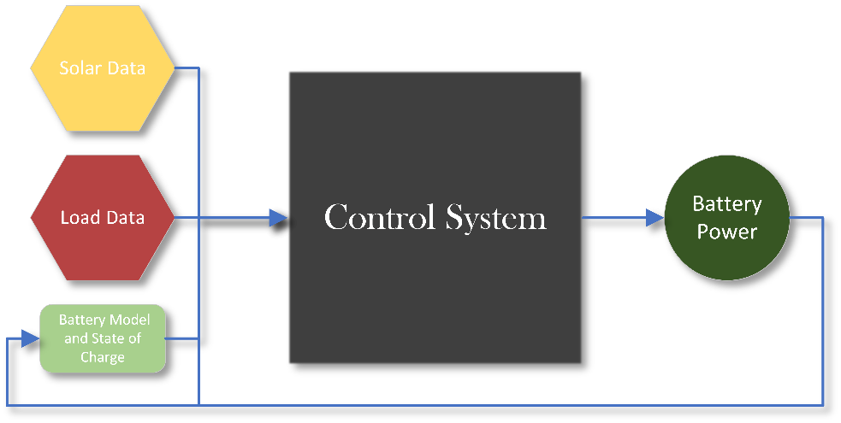

Figure : PV Self-Consumption Closed Loop Control System

One of the major benefits of a system like this is its time independence. The output (being the batteries next power value) is only dependent on the current values of the solar, house, battery power and battery state of charge. What this means is that this system can be implemented as a simple logic circuit and can react as quickly to changes in solar and load data as the designed control system will allow. The results of system like this often result in the battery being charged to full in the early morning sun and discharged to empty as the sun goes down and into the early night. A typical example of this might be as the following figure describes:

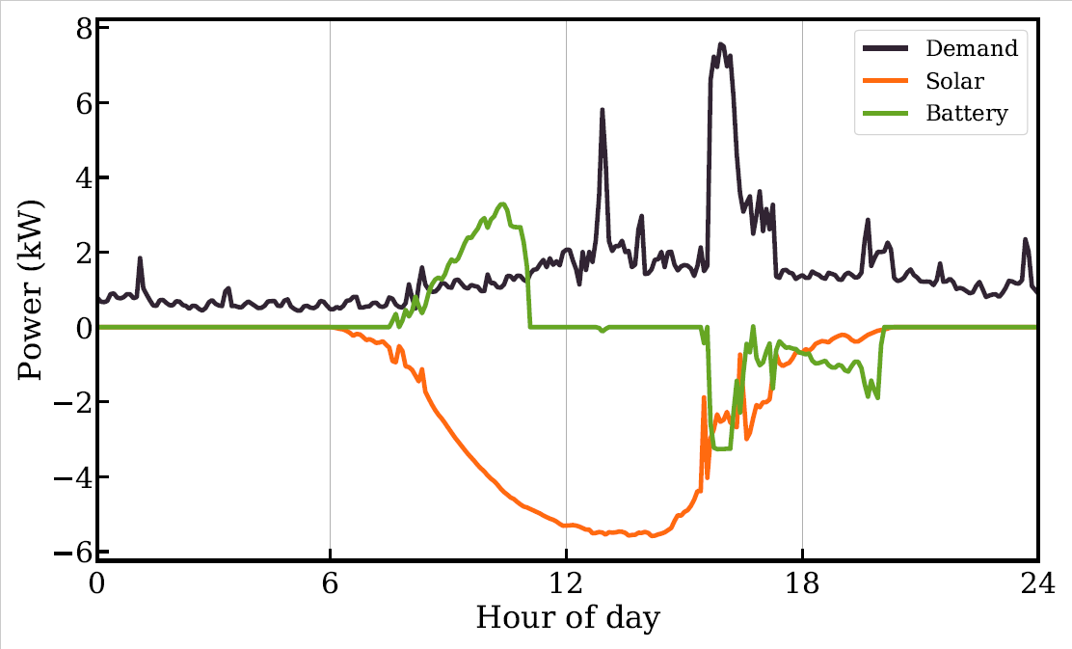

Figure : Typical PV-Self Consumption Battery 24 Hour Response

For reference the battery capacity in the example shown in Figure 3 is approximately 6.2 kWh. However, this response is not always what is desired. In some cases, reducing peak energy import, or import and export during a period or throughout the whole day can save more money and/or be more energy efficient. This type of control is described in most cases by the following equation:

$$\min\left(grid\right)[24 hours]= \min\left(Battery+House+Solar\right)[24 hours]$$

What this also means is that a 24 hour predicition of the house and solar values is needed for this case and therefore can be represented functionally by the following diagram:

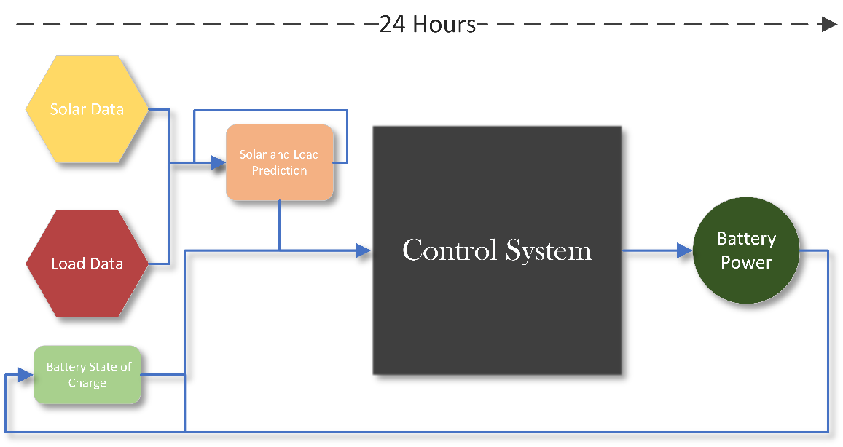

Figure : Peak Minimisation Closed Loop Control System

A typical example of this using the same data and battery capacity of that in Figure 3 might be as the following figure describes:

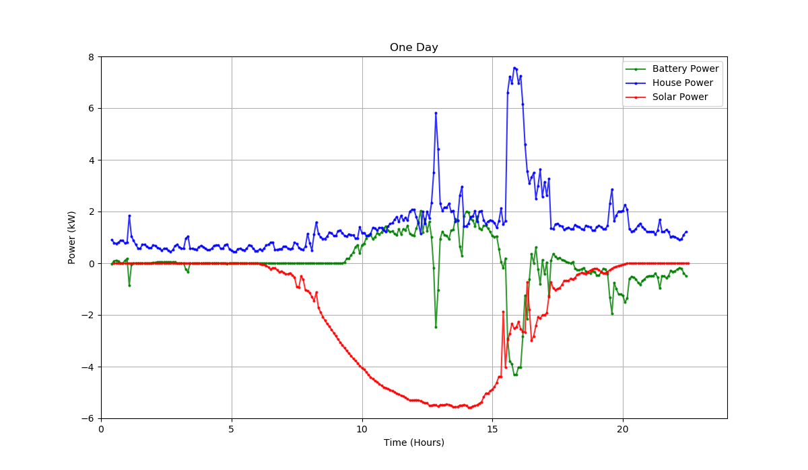

Figure : Typical Peak Minimisation Battery 24 Hour Response

Ignoring the empty data points (this is because Figure 4 was obtained from a real time graph where previous points are removed as the simulation progresses), the figure shows a vastly different battery response in comparison to that of Figure 3. Keep in mind that the response in Figure 4 was generated using a perfect prediction of solar and house data.

Even with these two control methods, neither can guarantee the battery will always have enough charge during the day’s usual peak load times, which may be when the price of import grid power is significantly higher and therefore, the system may be most effective by zeroing the grid during this time specifically. A known method of control that can be used for this is known as load shifting. The terms PV self-consumption and load shifting are often used interchangeably in energy storage literature; however, for this report, load shifting refers specifically to open loop control of the battery using a prediction of the solar curve, though still aims to solve the same equation: $Battery+House+Solar=0$. The response of this type of control is generally a smoother curve of what is shown in the battery response of Figure 3, meaning it often does not react to sharp changes in user energy consumption. This is because load-shifting by this definition is not implemented as a real-time control system and relies on a fixed prediction of the solar generation curve and therefore, generates a fixed battery response. Hence a load-shifting only system often acts as an open-loop control model with a 24-hour time-step, and can be represented functionally by the following diagram:

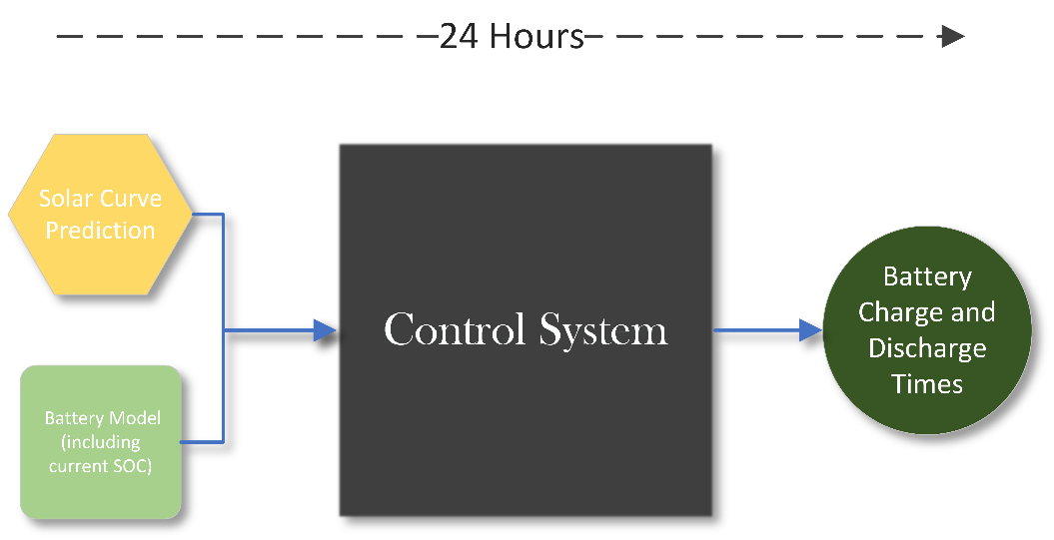

Figure : Load-Shifting Open-Loop Control System

One of the key differences of load shifting and peak minimisation is allowing the battery to charge from the grid, if not enough solar is available. The most obvious reason this may be beneficial, is ensuring the battery gets to maximum capacity during times of cheap grid import prices, so the user can avoid importing grid power during times of high prices as much as the battery will allow.

All of these control systems have different use cases and are more or less effective, depending on the user’s Tariff model (energy provider pricing system), location, budget, battery capacity, and many other factors. It can also be very difficult to know what type of control the battery provider will actually use for the user’s system. The following table describes very generally what each of these control methodologies need to function correctly:

Table : Generalised Comparison of Typical Battery Control Methods

|  |  |  |  |  |
| --- | --- | --- | --- | --- |
|  | Requires Direct Feed of Data (Solar/House/Grid) | Often Used as a ‘Real Time’ System | Needs Updating Future Data Prediction | Can Charge Battery from Grid if Necessary |
| PV Self – Consumption (Closed Loop) | YES | YES | NO | NO |
| Peak Minimisation | YES | YES/NO | YES | YES |
| Load Shifting (Open Loop) | NO | NO | YES | YES |

Table 1 shows of these three simplified control methods, none of them share the same requirements. The one box that states a yes/no is there because the prediction for the solar and house data can and is often also updated in real-time (rather than every 24 hours), though this of course adds extra computational time to each time-step. Along with these requirements it is also important to understand the most valuable use cases for each of these control methods:

* PV Self – Consumption (Closed Loop):
  + Advantageous Use Case: Any instantaneous changes in input data will result in a time-step dependent change in battery power. Such as if a user begins using power during the day and the battery has charge, it will attempt to account for this immediately.
  + Disadvantageous Use Case: If all battery capacity is consumed before high grid import prices begin, it may have been worth not using the battery until this point, but because this system is not dependent on time in any way, this would not occur.
* Peak Minimisation (Closed Loop):
  + Advantageous Use Case: Where pricing is in some way measured by peak energy usage or it makes more financial sense to minimise grid power over any extended period of time.
  + Disadvantageous Use Case: If the prediction does not account for peaks in household energy usage, or it makes most sense to completely zero the grid during a particular period of the day.
* Load Shifting (Open Loop):
  + Advantageous Use Case: Making sure the battery is correctly charged for when grid import prices arrive (almost always in the evening). Under many systems, this control method may behave almost the same as PV self-consumption and could be easier to implement.
  + Disadvantageous Use Case: Using a bad prediction, such as using a very sunny solar curve on a very rainy day, making the battery charge almost entirely off of the grid. Or just discharging at times when the battery is not needed.

So, the important question becomes: ‘How do we know which control option makes most sense at any given time on any given day?’ and the answer is unfortunately we don’t, just like using any one of these control methods by themselves will result in scenarios where they perform unfavourably. But, we can however, make a very good estimate. The reason we can make this estimate at all is for a number of reasons relating to optimisation criteria, but the two major reasons are:

1. The data for each day in PV solar systems is often very similar and follows similar curves and trends, even with household energy consumption and therefore, prediction methods for future data do not need to be overly complicated, greatly reducing computational overhead and increasing prediction accuracy.
2. All of these control methods share similar input data, and more importantly, almost the same objective: to save energy for the system and money for the user.

This is why a higher-level control system can be used, where these control methods are now objective functions to be compared in optimisation. Also, including the import and export Tariff information provides the addition for purely financial based objectives. This control system can now be represented functionally by the following diagram:

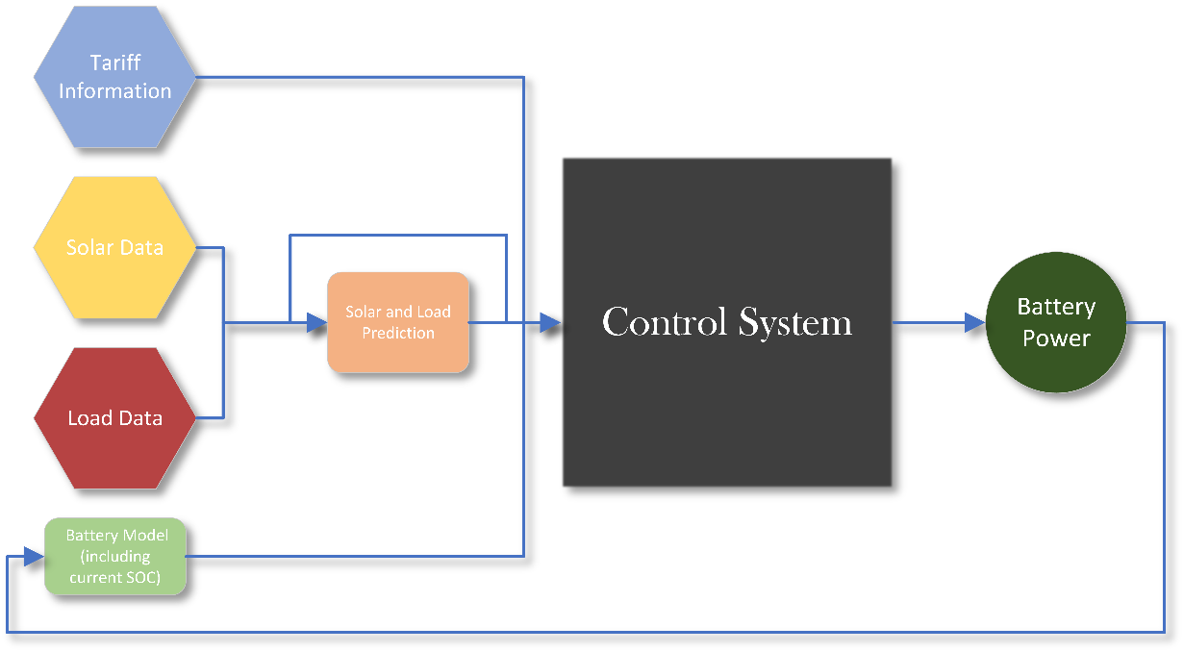

Figure : Optimisation Battery Control System

## Input Data Systems

For the control system to use the various data types it needs; solar, house/load, battery, etc. it needs systems in place to obtain and store this information. Different PV models will use different protocols to do this, though one commonly used, and well understood method is communication via servers. Using this method allows data to be arranged and categorised via server addresses, meaning accessing the correct data can be as simple as knowing which address it is stored in. Solar systems may choose to create a separate server for load information, making a total of three servers including one for the battery. These server systems may come in many forms such as ‘TCP’ or ‘UDP’ and Modbus ???, though the principle of obtaining the data remains the same. However, there is often another sub-system that will directly handle the data from the servers before it can be used by the control system. This sub-system is often known as the drivers, and are hence situated in this system in the following way:

FIGURE

There are two main reasons these drivers in most cases need to exist:

1. One system may involve a variety of server protocols with its various devices and the drivers ensure that even with information coming in different forms, the control system does not need to care and should always receive information in the same format.
2. The drivers control the flow of information, this helps greatly in synchronising data, and simplifying data handling for the control system.

Many systems will use different ways of controlling the data flow, though usually involve one of the two major asynchronous and synchronous data protocols. Those being the ‘publish/subscribe model’ (pub-sub) and the ‘request/reply model’ (req-rep). The pub-sub model means that the control system will subscribe to the driver and only receive data when the driver publishes, so the data flow is handled mostly on the driver side. The req-rep model means that the control system will only receive new data when it requests it from the driver, so the data flow is handled mostly by the control system. The following figure shows more accurately how each of these models work logically:

FIGURE

The servers and drivers will ensure that communication is structured, effective and controlled, but generally do nothing to ensure the data’s validity. Therefore, filtering becomes necessary, as without it, one outlying value could significantly decrease the accuracy of the entire control system for an extended period. Data filtering can be performed at many steps in the input data’s logical flow, though is most commonly performed either by the drivers or within the control system. For the purposes of higher-level control systems, it often makes more sense to filter the data within the control system, as filtering may be something that needs altering or even dynamic control, and the drivers typically are a static program. There are numerous filters that exist for one-dimensional data filtering including [???], though a well-established example for this type of data would be the Kalman filter. This filter works by establishing a prediction model of new data with an associated probability (prior), and updating this prediction model based on new measurements with an associated covariance and new probability (posterior), the one-dimensional Kalman filter is the simplest version of this, and can be used to ‘smooth’ data, or update any data model based on new information. For the optimisation-based control system, this filter can be used in two cases: To ’smooth’ out data arriving from the solar and house/load, as well as update the future prediction based on new data needed for optimisation. A basic example of this one-dimensional Kalman filter implemented in Python environment is outlined in the figure below:

FIGURE

As the code example shows this, filter has a ‘prediction’ step, an ‘update’ step and a ‘Kalman gain’ step which only executes if a new measurement is received and is used to update the current prediction.

With these systems in place, controlled and filtered data can be used by the control system, and in turn produce the battery power values required, which are written to the battery’s server.

## Battery Models

The batteries themselves are complicated devices, involving a large quantity of parameters that can define its characteristics. These involve its various limits, efficiencies, estimated lifespans, and other quantities that define how the battery behaves when being used. Some typical values of current market energy storage solutions available in Australia are shown below:

TABLE

It is important for these systems to then have a prediction of how the battery will respond to its inputs. For the real control system this can be used to measure the battery’s health and effectiveness. But for simulated systems, this can be used to test how the battery will perform, leading to testing on the entirety of the control system.

* Maybe a section about how much solar a typical AUS home produces

## Motivations

Blah

## Thesis Outline

Blah

# Background and Related Work

Blah

## Existing Battery Systems

Blah

## Current Viability Research

Blah

## BSGIP’s Work

Blah

# A Python Based Battery Control System

Blah

## Hardware Simulation and Program Abstraction

Blah

## System Capabilities and Limitations

Blah

## Testing Methods

Blah

## Results

Blah

# Discussion

Blah

## Technical Assumptions

Blah

## Results Implications

Blah

## Financial Incentives

Blah

# Conclusions

Blah

## Battery Systems’ Current Viability

Blah

## An Open-Source Solution

Blah

# Bibliography